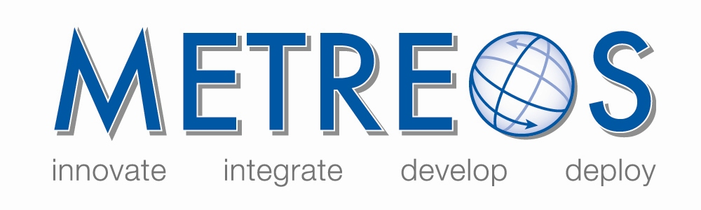
IP Communications Applications for Business Advantage

Metreos ClickToTalk 2.1

Copyright © 2005 Metreos Corporation
All Rights Reserved

Proprietary and Confidential Information
For Release under NDA Only

Metreos ClickToTalk
Metreos ClickToTalk™ is a speed dialing application permitting the calling of any party in a contact list with a single click. Metreos ClickToTalk can be used by anyone in a Cisco CallManager group using a Cisco 7940, 7960, or 7970 IP telephone.

A ClickToTalk user can select an entry from his or her Microsoft Outlook contact list, click a button on the Outlook tool bar, and ClickToTalk will dial that contact from that user’s IP phone. Conferencing and recording of calls are also supported. Recorded calls can be sent by e-mail to all call participants.

Integration with Cisco IP Phone Services enables the display of called party state on the phone. If, for example, an invited conferee did not answer, a message is displayed on your phone indicating that the party did not answer. A robust XML-over-HTTP API is also available, permitting easy integration into other applications such as instant messaging.

Metreos ClickToTalk ships with a plug-in for Microsoft Outlook. Other such plug-ins can be easily developed by your staff or integrator to permit calls from any HTTP-capable endpoint.

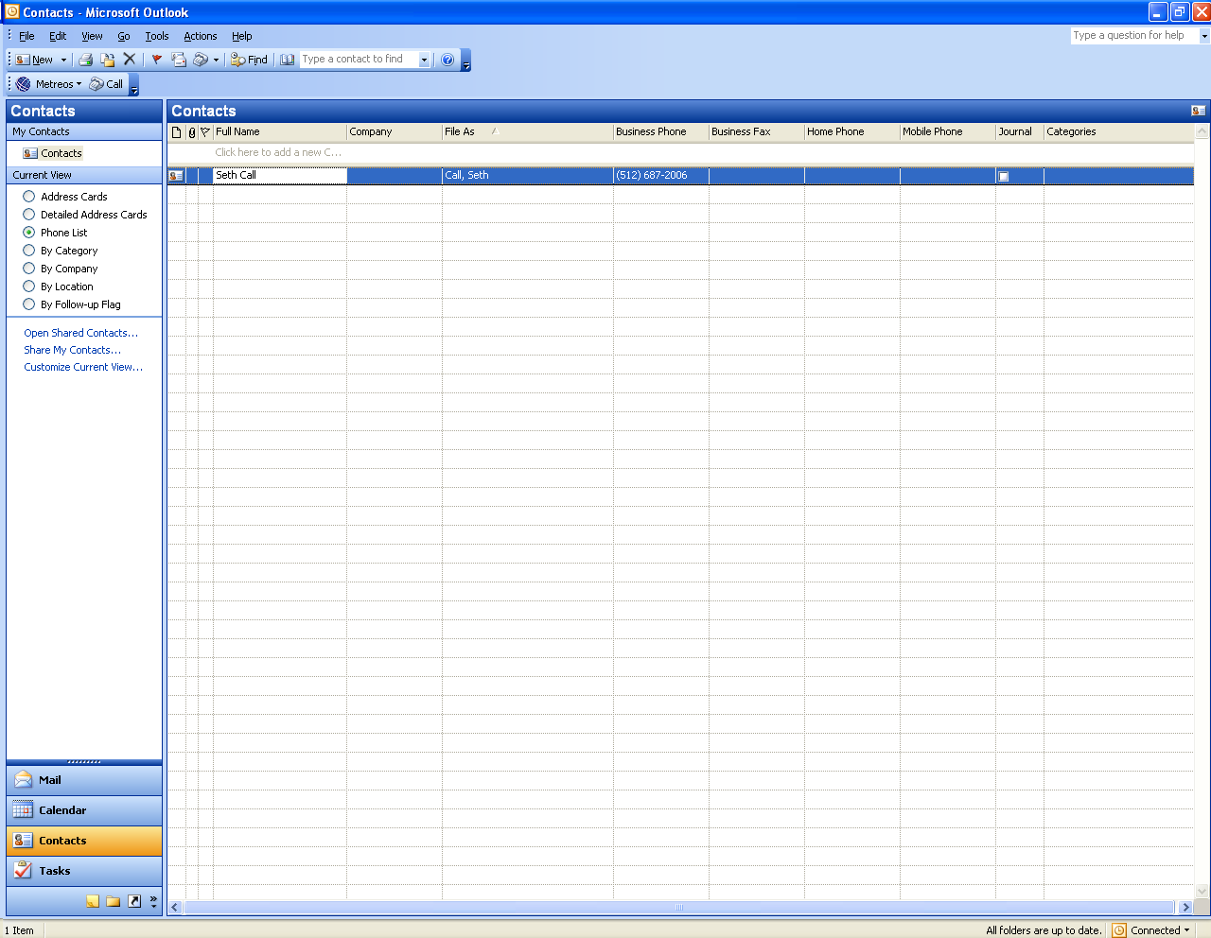
Figure 1: ClickToTalk Presence on Outlook Toolbar

Before You Begin
Before installing the ClickToTalk Outlook plug-in, you or the administrator should ensure the following:
- The Metreos runtime environment is running, and that the administrator has informed you of the IP address and port number ClickToTalk should use for connectivity.
- You or the administrator has registered a Metreos Application Suite account for you, and that you have the user name and password for this account at hand. Refer to the Metreos Communications Environment 2.1 Application Suite Administration Guide for more information.
- You or the administrator has registered the IP phone to be used to dial your ClickToTalk calls, as the primary device in your Metreos Application Suite account.
- You or the administrator has associated this same IP phone device with a Cisco CallManager user account. Refer to Cisco documentation for more information.

Installing the Outlook Plug-In
You should first uninstall any existing Metreos ClickToTalk plug-in, by navigating to the Windows Start menu → Control Panel → Add or Remove Programs → Metreos ClickToTalk plug-in for uninstallation, if it was previously installed.

Your Metreos Application Suite administrator can provide you the installation file for the ClickToTalk Outlook plug-in. The installation file name is setup.exe, unless renamed by the administrator. Double-click the setup.exe file to begin installation. The system displays an install wizard to guide you through the installation process.

When the installation is complete, start Microsoft Outlook and the ClickToTalk button will be found on the Outlook toolbar.

Configuring the Outlook Plug-In
Before using ClickToTalk for the first time, you must configure ClickToTalk with the information required to

- Log you into the Metreos Application Suite server
- Forward to you any call recordings you request

The configuration information will be saved in the registry. It is therefore necessary to configure the Outlook plug-in only after installation of ClickToTalk, or in the event that your logon information changes.

Clicking the ClickToTalk button on the Outlook toolbar, launches presents a menu with a single item: Settings… Click Settings to launch the Metreos ClickToTalk Settings dialog as shown:

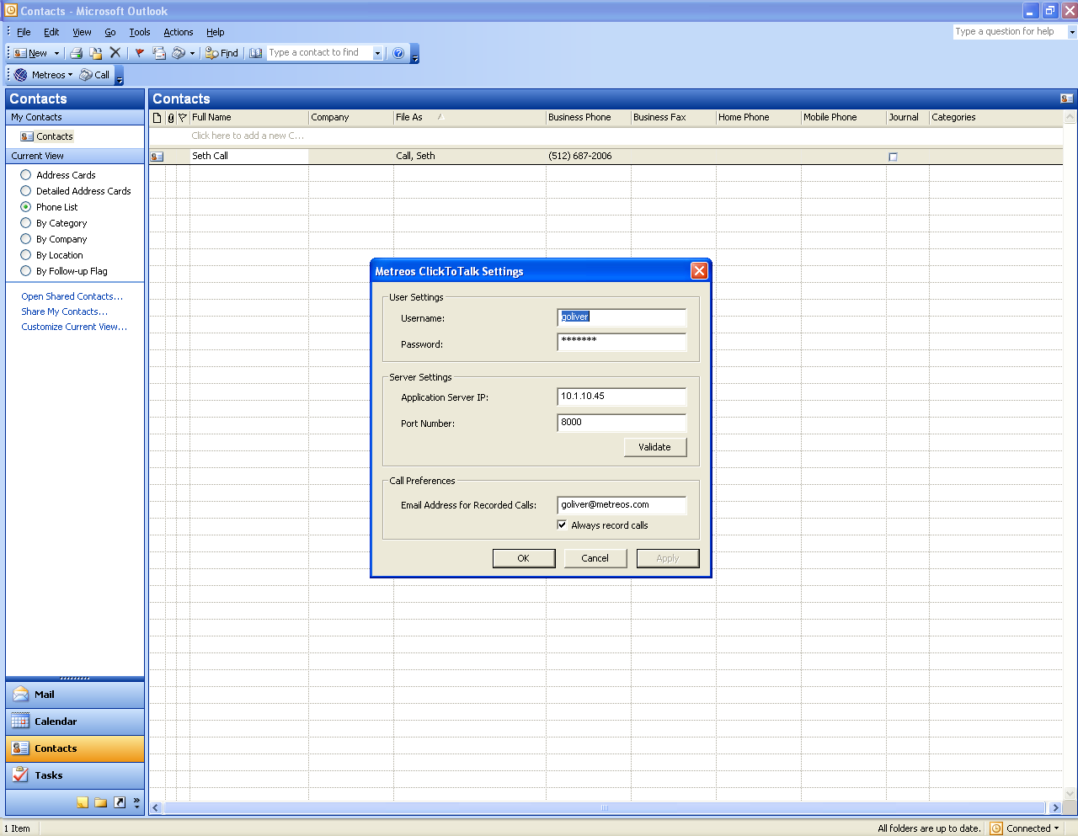
Figure 2: Metreos ClickToTalk Settings
Enter the following information:
- Username – Enter your Metreos Application Suite username supplied by the administrator.
- Password – Enter your Metreos Application Suite password supplied by the administrator.
- Metreos Application Server – Enter the Metreos Application Suite IP address supplied by the administrator.
- Port Number – Enter the Metreos Application Suite port number supplied by the administrator.
- Email Address for Recorded Calls/Always record calls – Enter the email address to which you want your requested call recordings sent.
- Always record calls – Check this box if you want to record all the calls you initiate.

Click the Validate button, to verify connectivity. Proceed to the next section, Verifying Connectivity, on page 6, and follow the instructions.

Verifying Connectivity
Clicking Validate on the Metreos ClickToTalk Settings dialog ensures that connectivity to the Metreos Application Suite runtime environment can be established. A progress bar will be displayed, after which the system will present a message indicating either that a connection was established, or the connection attempt failed. If successful, the one-time setup is complete, and Metreos ClickToTalk is ready to dial your calls with one click.

If connectivity was not established
If connectivity could not be established, ensure that

- The Metreos runtime environment is active.
- You have entered the correct IP address and port number for the Application Runtime Environment in the Metreos ClickToTalk Settings dialog (Figure 2)
- Your Metreos Application Suite user account has a password associated with it.
- You have entered the correct account name and password for your Metreos Application Suite user account in the Metreos ClickToTalk Settings dialog.

Making a Call
To make a call, select an entry in your contact list, and click the Call button located on the ClickToTalk Outlook toolbar. ClickToTalk presents a dialog with the contact information, which you can modify if necessary:

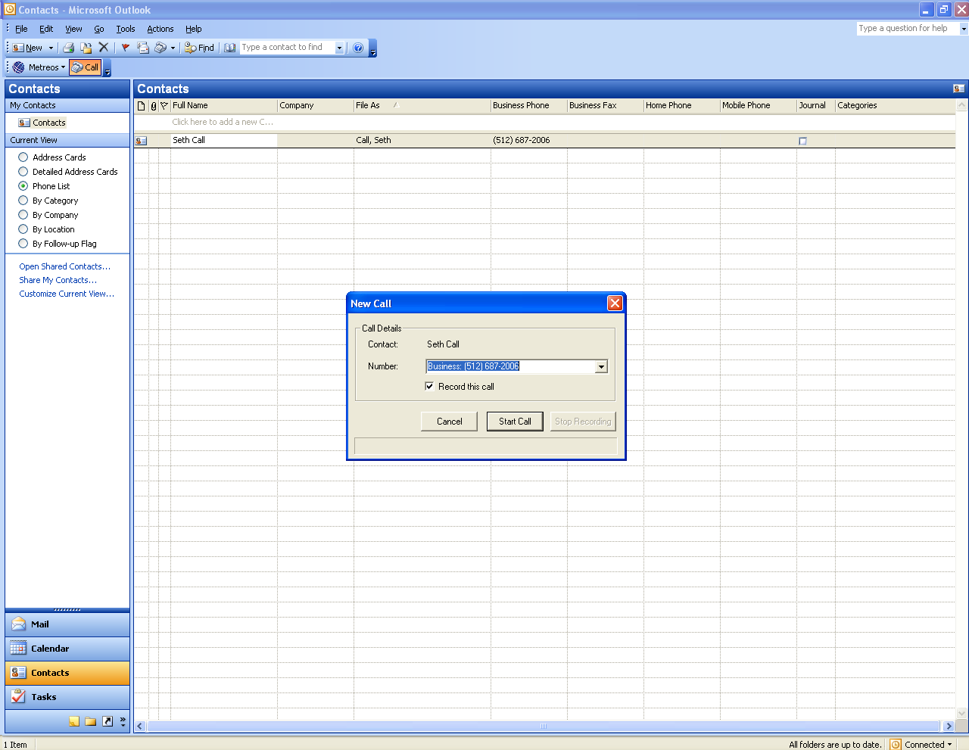
Figure 3: Metreos ClickToTalk Contact Dialog
The contact telephone number that you can modify will be displayed. Your IP phone will dial the selected party and begin talking when the call is answered.

Recording Your Call
At the time you click to talk, a dialog is displayed with the contact telephone number. To record the call, check the Record this call box.

Note: If you specified that all calls were to be recorded in the ClickToTalk Settings it is not necessary to specify Record this call again here.

To stop recording the call, press the Stop Recording button, also found on the contact dialog.

Conference Calls
To begin a conference call, select multiple (up to four) entries from your contact list and click to talk:

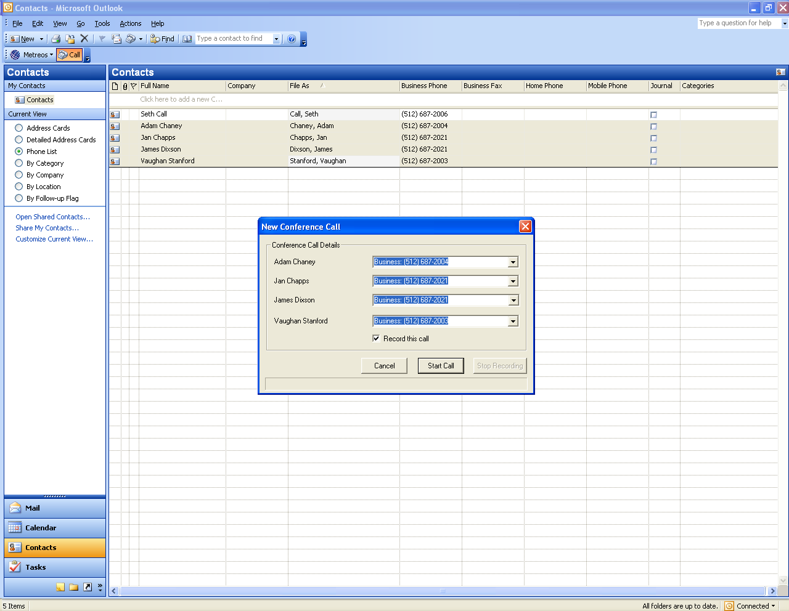
Figure 4: Metreos ClickToTalk Conference Call
If one or more parties fail to answer, a message ClickToTalk will be present a message on your phone display indicating which contacts did not answer. Refer to Recording Your Call on page 7 to record your conference call.

